UseCase convert Mb to Kb – own pipe stage

I want to convert (at least)1 column in my input file from Mb to Kb.

Notes:
- my input file is called TEST FILE
- my stage is called SICONV REXX
- CALLPIPE is used in the stage for my “norma” PIPE processing
- Testing is done: PIPE < TEST FILE * | siconv <options> | cons

- The test file contains the following:
12 25M 123 aa
13 12M 14 bb
22 22M 144 cc
24 100m 146 dd
31 22M 558 ee
38 29M 199 ff
40 88M 390 gg
44 72m 30 hh
47 123m 2950 ii
50 1m 13 jj
59 23m 148 kk

- Let’s see what we get with this initial setup:
/* SICONV REXX convert from 1 SI unit to another */

/* The units we are going to support, to be extended!! */
K=1024 /* Kilo */ ; M=K*K /* Mega */ ; G=K*M /* Giga */
T=G*K /* Tera */
units='B K M G T'
/* Reading input */
Parse Upper Arg inputline

'CALLPIPE (end ?)',
'*:',
'| buffer',
'| *:'
Return

- Continuing with refining the working of the current setup:
/* SICONV REXX convert from 1 SI unit to another */

/* The units we are going to support, to be extended!! */
K=1024 /* Kilo */ ; M=K*K /* Mega */ ; G=K*M /* Giga */
T=G*K /* Tera */
units='B K M G T'
/* Reading input */
Parse Upper Arg inputline

'CALLPIPE (end ?)',
'*:',
'| buffer',
'| stem input.'

Do w=1 To Words(inputline) By 2
loc=Word(inputline,w)
cnv=Word(inputline,w+1)
Parse Value cnv With fr'2'to .
Say loc cnv fr to
End w
Return

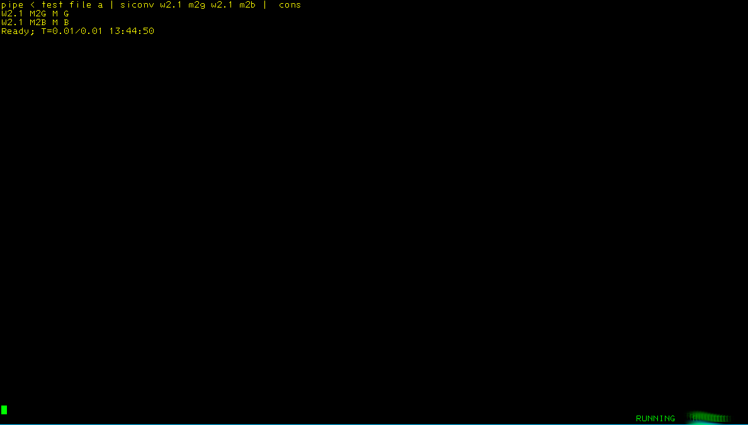
- The processing of the input seems to be working some more tuning:
/* SICONV REXX convert from 1 SI unit to another */

/* The units we are going to support, to be extended!! */
K=1024 /* Kilo */ ; M=K*K /* Mega */ ; G=K*M /* Giga */
T=G*K /* Tera */
units='B K M G T'
/* Reading input */
Parse Upper Arg inputline

'CALLPIPE (end ?)',
'*:', /* Read all records from caller */
'| buffer', /* Prevent stall */
'| stem input.' /* Store as */

/*---------------------------------------------------------------+
| Loop thru the input with 2 words at a time |
+---------------------------------------------------------------*/
Do w=1 To Words(inputline) By 2
loc=Word(inputline,w) /* Take location */
cnv=Word(inputline,w+1) /* Take the conversion */
Parse Value cnv With fr'2'to . /* Split the conversion into parts */
'CALLPIPE (End ?)',
'stem input.', /* Take this stem */
'| buffer', /* prevent a loop */
'| change anycase 'loc' °'fr'°°', /* Remove the SI signs if present*/
'| stem input.' /* Rewrite the stem*/
End w
'CALLPIPE (end ?)',
'stem input.', /* Take the stem */
'| *:' /* Feed 2 caller */
Return
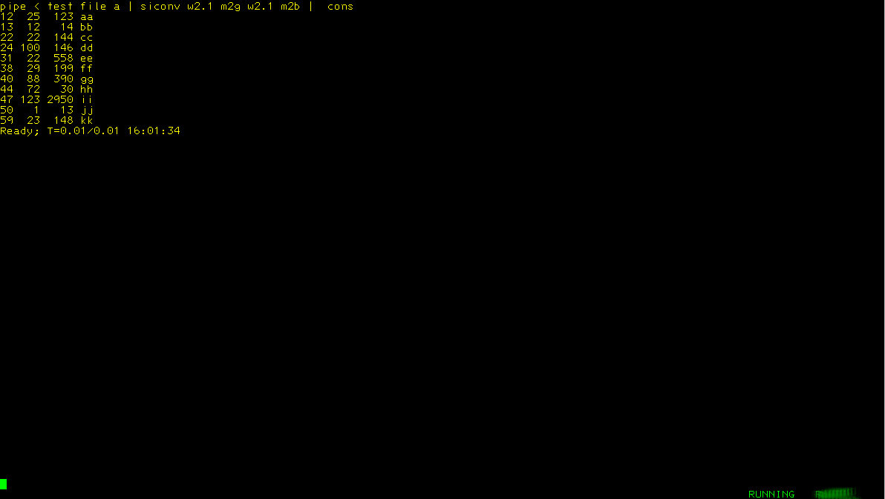
- Now we are adding the multiplication so we get the bytes added to the record
/* SICONV REXX convert from 1 SI unit to another */

numeric digits 64 /* So we see the numbers */
/* The units we are going to support, to be extended!! */
K=1024 /* Kilo */ ; M=K*K /* Mega */ ; G=K*M /* Giga */
T=G*K /* Tera */
units='B K M G T'
/* Reading input */
Parse Upper Arg inputline

'CALLPIPE (end ?)',
'*:', /* Read all records from caller */
'| buffer', /* Prevent stall */
'| stem input.' /* Store as */

/*---------------------------------------------------------------+
| Loop thru the input with 2 words at a time |
+---------------------------------------------------------------*/
Do w=1 To Words(inputline) By 2
loc=Word(inputline,w) /* Take location */
cnv=Word(inputline,w+1) /* Take the conversion */
Parse Value cnv With fr'2'to . /* Split the conversion into parts */
Interpret('factor='fr) /* We need to multiply by this */
Interpret('diviso='to) /* We need to divide by this */
'CALLPIPE (End ?)',
'stem input.', /* Take this stem */
'| buffer', /* Prevent a loop */
'| change anycase 'loc' °'fr'°°', /* Remove the SI sign if present */
'| specs 1;* 1', /* Take the complete record */
' a: 'loc' .', /* Select this column */
' set #0:=a*'factor, /* Start the multiplication */
' print #0 nw', /* Add to the end of the record */
'| stem input.' /* Rewrite the stem */
End w
/*---------------------------------------------------------------+
| Send the changed records to the caller... |
+---------------------------------------------------------------*/
'CALLPIPE (end ?)',
'stem input.', /* Take the stem */
'| *:' /* Feed 2 caller */
Return

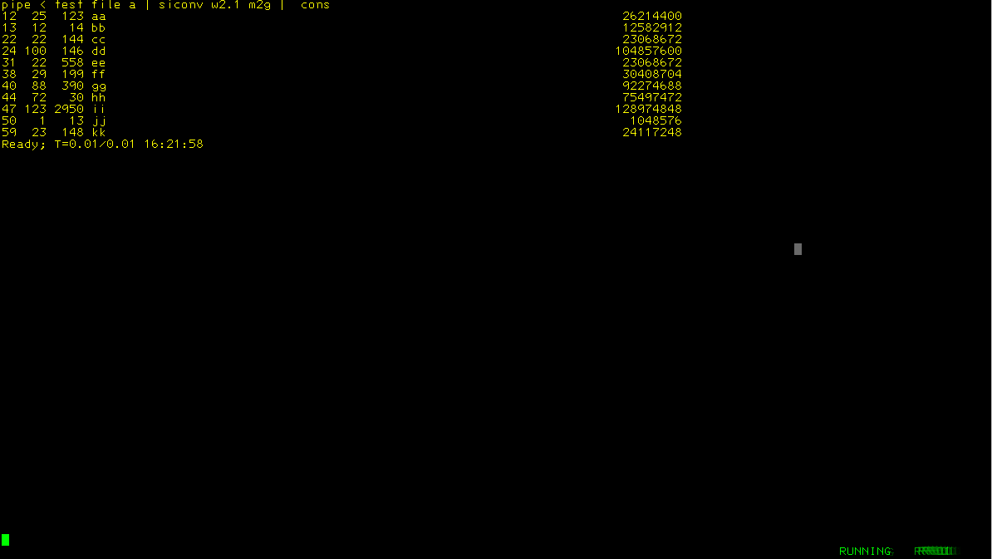
- Now we need to divide the last column by the output (G)
/* The units we are going to support, to be extended!! */
K=1024 /* Kilo */ ; M=K*K /* Mega */ ; G=K*M /* Giga */
T=G*K /* Tera */
units='B K M G T'
/* Reading input */
Parse Upper Arg inputline

'CALLPIPE (end ?)',
'*:', /* Read all records from caller */
'| buffer', /* Prevent stall */
'| stem input.' /* Store as */

/*---------------------------------------------------------------+
| Loop thru the input with 2 words at a time |
+---------------------------------------------------------------*/
Do w=1 To Words(inputline) By 2
loc=Word(inputline,w) /* Take location */
cnv=Word(inputline,w+1) /* Take the conversion */
Parse Value cnv With fr'2'to . /* Split the conversion into parts */
Interpret('factor='fr) /* We need to multiply by this */
Interpret('diviso='to) /* We need to divide by this */
'CALLPIPE (End ?)',
'stem input.', /* Take this stem */
'| buffer', /* Prevent a loop */
'| change anycase 'loc' °'fr'°°', /* Remove the SI sign if present */
'| specs 1;* 1', /* Take the complete record */
' a: 'loc' .', /* Select this column */
' set #0:=a*'factor, /* Start the multiplication */
' print #0 nw', /* Add to the end of the record */
'| specs w1;-2 1', /* Take the record minus the last column */
' b: w-1;-1 .', /* Take the last column/word */
' set #1:=b/'diviso, /* Divide it */
' print #1 nw', /* Add it as last word in the record */
'| stem input.' /* Rewrite the stem */
End w
/*---------------------------------------------------------------+
| Send the changed records to the caller... |
+---------------------------------------------------------------*/
'CALLPIPE (end ?)',
'stem input.', /* Take the stem */
'| *:' /* Feed 2 caller */
Return

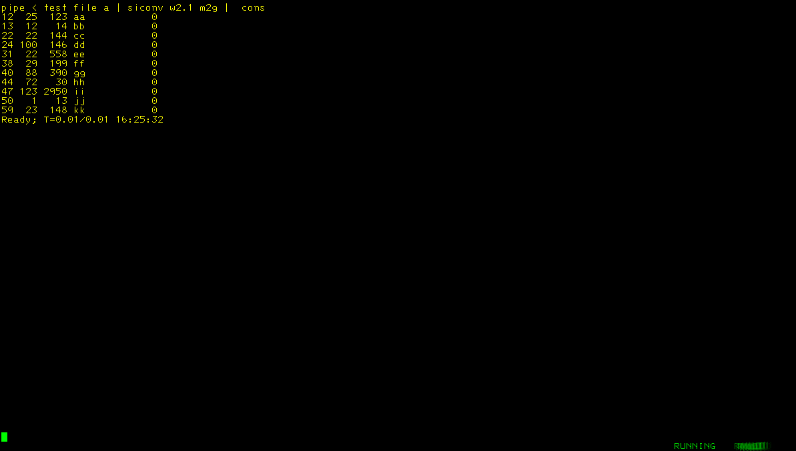
- Mmmm....the numbers are a bit low...
/* SICONV REXX convert from 1 SI unit to another */

numeric digits 64 /* So we see the numbers */
/* The units we are going to support, to be extended!! */
K=1024 /* Kilo */ ; M=K*K /* Mega */ ; G=K*M /* Giga */
T=G*K /* Tera */
units='B K M G T'
/* Reading input */
Parse Upper Arg inputline

'CALLPIPE (end ?)',
'*:', /* Read all records from caller */
'| buffer', /* Prevent stall */
'| stem input.' /* Store as */

/*---------------------------------------------------------------+
| Loop thru the input with 2 words at a time |
+---------------------------------------------------------------*/
Do w=1 To Words(inputline) By 2
loc=Word(inputline,w) /* Take location */
cnv=Word(inputline,w+1) /* Take the conversion */
Parse Value cnv With fr'2'to . /* Split the conversion into parts */
Interpret('factor='fr) /* We need to multiply by this */
Interpret('diviso='to) /* We need to divide by this */
'CALLPIPE (End ?)',
'stem input.', /* Take this stem */
'| buffer', /* Prevent a loop */
'| change anycase 'loc' °'fr'°°', /* Remove the SI sign if present */
'| specs 1;* 1', /* Take the complete record */
' a: 'loc' .', /* Select this column */
' set #0:=a*'factor, /* Start the multiplication */
' print #0 nw', /* Add to the end of the record */
'| specs w1;-2 1', /* Take the record minus the last column */
' b: w-1;-1 .', /* Take the last column/word */
' set #1:=b/'diviso, /* Divide it */
' print #1 picture -------9.99 nw', /* Adjust layout using picture */
'| stem input.' /* Rewrite the stem */
End w
/*---------------------------------------------------------------+
| Send the changed records to the caller... |
+---------------------------------------------------------------*/
'CALLPIPE (end ?)',
'stem input.', /* Take the stem */
'| *:' /* Feed 2 caller */
Return

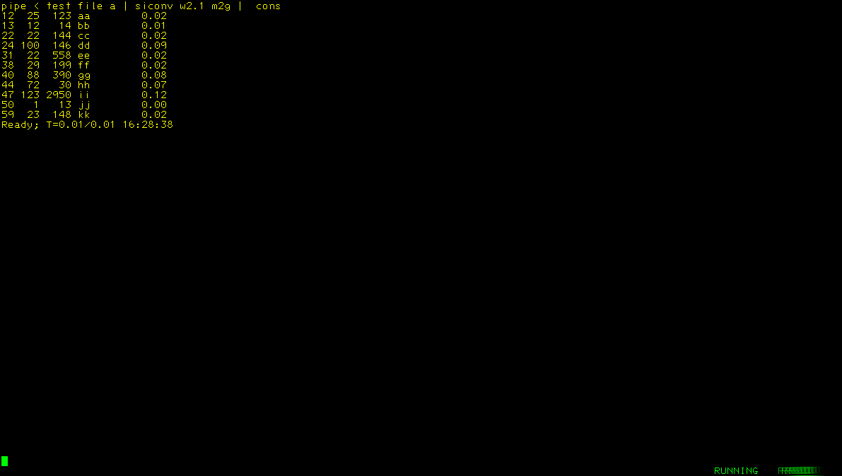
- Now we add some checking to see if the conversion syntax is correct
/* SICONV REXX convert from 1 SI unit to another */

numeric digits 64 /* So we see the numbers */
/* The units we are going to support, to be extended!! */
K=1024 /* Kilo */ ; M=K*K /* Mega */ ; G=K*M /* Giga */
T=G*K /* Tera */
units='B K M G T'
/* Reading input */
Parse Upper Arg inputline

'CALLPIPE (end ?)',
'*:', /* Read all records from caller */
'| buffer', /* Prevent stall */
'| stem input.' /* Store as */

/*---------------------------------------------------------------+
| Loop thru the input with 2 words at a time |
+---------------------------------------------------------------*/
Do w=1 To Words(inputline) By 2
loc=Word(inputline,w) /* Take location */
cnv=Word(inputline,w+1) /* Take the conversion */
Parse Value cnv With fr'2'to . /* Split the conversion into parts */
Call Check_Conversion
Interpret('factor='fr) /* We need to multiply by this */
Interpret('diviso='to) /* We need to divide by this */
'CALLPIPE (End ?)',
'stem input.', /* Take this stem */
'| buffer', /* Prevent a loop */
'| change anycase 'loc' °'fr'°°', /* Remove the SI sign if present */
'| specs 1;* 1', /* Take the complete record */
' a: 'loc' .', /* Select this column */
' set #0:=a*'factor, /* Start the multiplication */
' print #0 nw', /* Add to the end of the record */
'| specs w1;-2 1', /* Take the record minus the last column */
' b: w-1;-1 .', /* Take the last column/word */
' set #1:=b/'diviso, /* Divide it */
' print #1 picture -------9.99 nw', /* Adjusting layout using picture */
'| stem input.' /* Rewrite the stem */
End w
/*---------------------------------------------------------------+
| Send the changed records to the caller... |
+---------------------------------------------------------------*/
'CALLPIPE (end ?)',
'stem input.', /* Take the stem */
'| *:' /* Feed 2 caller */
Return

Check_Conversion:
/*---------------------------------------------------------------+
| Check if the conversion is correct... |
+---------------------------------------------------------------*/
If Pos(fr,units)=0 Then Do
Say fr 'in 'cnv' is invalid’
Exit 99
End
If Pos(to,units)=0 Then Do
Say to 'in 'cnv' is invalid’
Exit 99
End
Return

- Test input: pipe < test file * | siconv x2g | cons
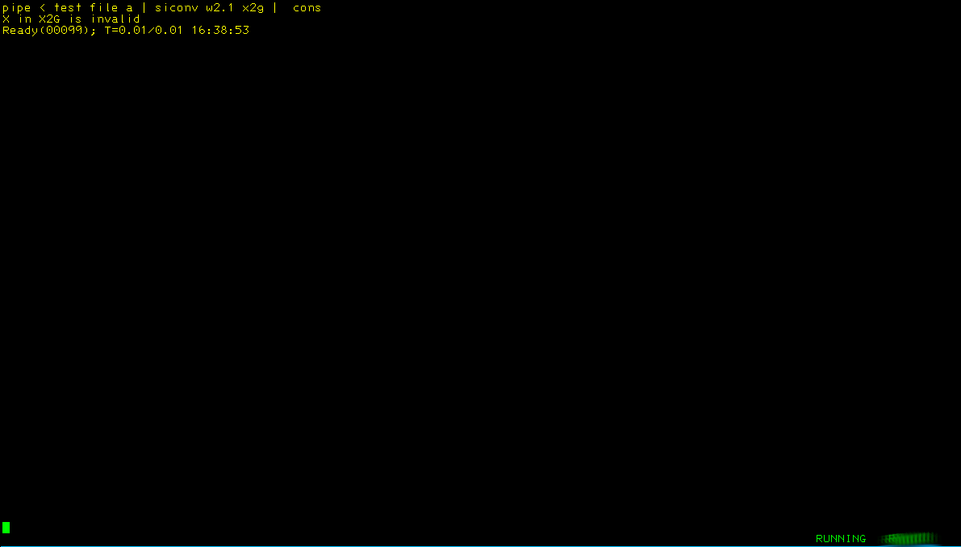
Test input: pipe < test file * | siconv m2x | cons

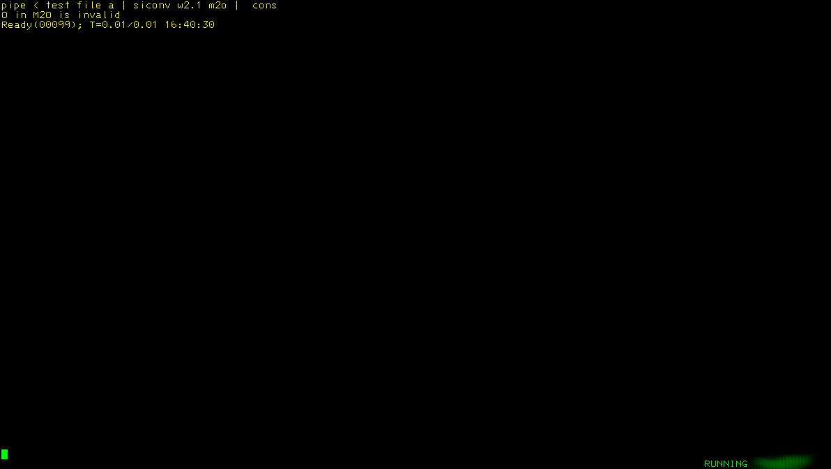
- Some more testing added, checking to see if the from and to in the conversion are equal
/* SICONV REXX convert from 1 SI unit to another */

numeric digits 64 /* So we see the numbers */
/* The units we are going to support, to be extended!! */
K=1024 /* Kilo */ ; M=K*K /* Mega */ ; G=K*M /* Giga */
T=G*K /* Tera */
units='B K M G T'
/* Reading input */
Parse Upper Arg inputline

'CALLPIPE (end ?)',
'*:', /* Read all records from caller */
'| buffer', /* Prevent stall */
'| stem input.' /* Store as */

/*---------------------------------------------------------------+
| Loop thru the input with 2 words at a time |
+---------------------------------------------------------------*/
Do w=1 To Words(inputline) By 2
loc=Word(inputline,w) /* Take location */
cnv=Word(inputline,w+1) /* Take the conversion */
Parse Value cnv With fr'2'to . /* Split the conversion into parts */
Call Check_Conversion
Interpret('factor='fr) /* We need to multiply by this */
Interpret('diviso='to) /* We need to divide by this */
'CALLPIPE (End ?)',
'stem input.', /* Take this stem */
'| buffer', /* Prevent a loop */
'| change anycase 'loc' °'fr'°°', /* Remove the SI sign if present */
'| specs 1;* 1', /* Take the complete record */
' a: 'loc' .', /* Select this column */
' set #0:=a*'factor, /* Start the multiplication */
' print #0 nw', /* Add to the end of the record */
'| specs w1;-2 1', /* Take the record minus the last column */
' b: w-1;-1 .', /* Take the last column/word */
' set #1:=b/'diviso, /* Divide it */
' print #1 picture -------9.99 nw', /* Adjusting layout using picture */
'| stem input.' /* Rewrite the stem */
End w
/*---------------------------------------------------------------+
| Send the changed records to the caller... |
+---------------------------------------------------------------*/
'CALLPIPE (end ?)',
'stem input.', /* Take the stem */
'| *:' /* Feed 2 caller */
Return

Check_Conversion:
/*---------------------------------------------------------------+
| Check if the conversion is correct... |
+---------------------------------------------------------------*/
If fr=to Then Do /* They are equal, unneeded
Say cnv 'is invalid'
Exit 99
End
If Pos(fr,units)=0 Then Do /* From is not valid */
Say fr 'in 'cnv' is invalid'
Exit 99
End
If Pos(to,units)=0 Then Do /* To is not valid */
Say to 'in 'cnv' is invalid'
Exit 99
End
Return

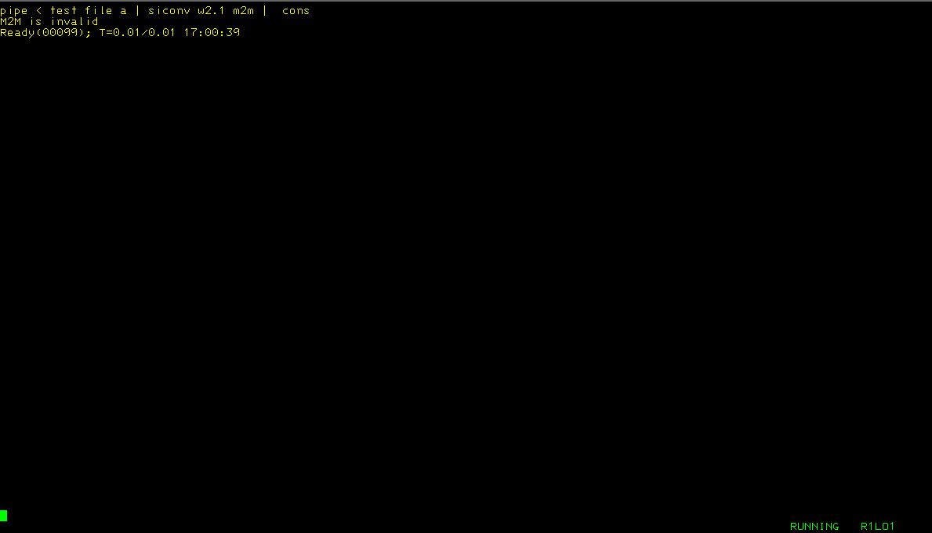
- Now I want the newly calculated values in the place of the original values:
/* SICONV REXX convert from 1 SI unit to another */

numeric digits 64 /* So we see the numbers */
/*---------------------------------------------------------------+
| The units we are going to support... |
+---------------------------------------------------------------*/
K=1024 /* Kilo */ ; M=K*K /* Mega */ ; G=K*M /* Giga */
T=G*K /* Tera */
units='B K M G T'
/*---------------------------------------------------------------+
| Gettuing the input |
+---------------------------------------------------------------*/
Parse Upper Arg inputline
/*---------------------------------------------------------------+
| We expect input like: w2.1 m2g w3.1 b2g |
| We will cater for w and word |
+---------------------------------------------------------------*/
'CALLPIPE (end ?)',
'*:', /* Read all records from caller */
'| buffer', /* Prevent stall */
'| stem input.', /* Store as */
'?', /* A 2nd pipe started */
'var inputline', /* Take this */
'| change anycase °WORD°W°', /* Replace this */
'| var inputline' /* Re-write */
/*---------------------------------------------------------------+
| Loop thru the input with 2 words at a time |
+---------------------------------------------------------------*/
Do w=1 To Words(inputline) By 2
loc=Word(inputline,w) /* Take location */
Parse Value loc With 'W' strt '.' len . /* Split into usable parts */
rework='w1.'strt-1' 1 w-1;-1 nw w'strt+len';-2 nw' /* Do some rework */
cnv=Word(inputline,w+1) /* Take the conversion */
Parse Value cnv With fr'2'to . /* Split the conversion into parts */
Call Check_Conversion
Interpret('factor='fr) /* We need to multiply by this */
Interpret('diviso='to) /* We need to divide by this */
'CALLPIPE (End ?)',
'stem input.', /* Take this stem */
'| buffer', /* Prevent a loop */
'| change anycase 'loc' °'fr'°°', /* Remove the SI sign if present */
'| specs 1;* 1', /* Take the complete record */
' a: 'loc' .', /* Select this column */
' set #0:=a*'factor, /* Start the multiplication */
' print #0 nw', /* Add to the end of the record */
'| specs w1;-2 1', /* Take the record minus the last column */
' b: w-1;-1 .', /* Take the last column/word */
' set #1:=b/'diviso, /* Divide it */
' print #1 picture -------9.99 nw', /* Adjusting layout using picture */
'| specs 'rework, /* Re-align the layout of the records */
'| stem input.' /* Rewrite the stem */
End w
/*---------------------------------------------------------------+
| Send the changed records to the caller... |
+---------------------------------------------------------------*/
'CALLPIPE (end ?)',
'stem input.', /* Take the stem */
'| *:' /* Feed 2 caller */
Return

Check_Conversion:
/*---------------------------------------------------------------+
| Check if the conversion is correct... |
+---------------------------------------------------------------*/
If fr=to Then Do /* They are equal, unneeded */
Say cnv 'is invalid'
Exit 99
End
If Pos(fr,units)=0 Then Do /* From is not valid */
Say fr 'in 'cnv' is invalid'
Exit 99
End
If Pos(to,units)=0 Then Do /* To is not valid */
Say to 'in 'cnv' is invalid'
Exit 99
End
Return

- Now we add some more SI units and check if it works for w1.1
/* SICONV REXX convert from 1 SI unit to another */

numeric digits 64 /* So we see the numbers */
/*---------------------------------------------------------------+
| The units we are going to support... |
+---------------------------------------------------------------*/
/** B = to or from Bytes **/
K=1024 /* Kilo */ ; M=K*K /* Mega */ ; G=M*K /* Giga */
T=G*K /* Tera */ ; P=T*K /* Peta */ ; E=P*K /* Exa */
Z=E*K /* Zeta */ ; Y=Z*K /* Yotta*/
units='B K M G T P E Z Y'
/*---------------------------------------------------------------+
| Getting the input |
+---------------------------------------------------------------*/
Parse Upper Arg inputline
/*---------------------------------------------------------------+
| We expect input like: w2.1 m2g w3.1 b2g |
| We will cater for w and word |
+---------------------------------------------------------------*/
'CALLPIPE (end ?)',
'*:', /* Read all records from caller */
'| buffer', /* Prevent stall */
'| stem input.', /* Store as */
'?', /* A 2nd pipe started */
'var inputline', /* Take this */
'| change anycase °WORD°W°', /* Replace this */
'| var inputline' /* Re-write */
/*---------------------------------------------------------------+
| Loop thru the input with 2 words at a time |
+---------------------------------------------------------------*/
Do w=1 To Words(inputline) By 2
loc=Word(inputline,w) /* Take location */
Parse Value loc With 'W' strt '.' len . /* Split into usable parts */
rework='w1.'strt-1' 1 w-1;-1 nw w'strt+len';-2 nw' /* Do some rework */
cnv=Word(inputline,w+1) /* Take the conversion */
Parse Value cnv With fr'2'to . /* Split the conversion into parts */
Call Check_Conversion
Interpret('factor='fr) /* We need to multiply by this */
Interpret('diviso='to) /* We need to divide by this */
'CALLPIPE (End ?)',
'stem input.', /* Take this stem */
'| buffer', /* Prevent a loop */
'| change anycase 'loc' °'fr'°°', /* Remove the SI sign if present */
'| specs 1;* 1', /* Take the complete record */
' a: 'loc' .', /* Select this column */
' set #0:=a*'factor, /* Start the multiplication */
' print #0 nw', /* Add to the end of the record */
'| specs w1;-2 1', /* Take the record minus the last column */
' b: w-1;-1 .', /* Take the last column/word */
' set #1:=b/'diviso, /* Divide it */
' print #1 picture -------9.99 nw', /* Adjusting layout using picture */
'| specs 'rework, /* Re-align the layout of the records */
'| stem input.' /* Rewrite the stem */
End w
/*---------------------------------------------------------------+
| Send the changed records to the caller... |
+---------------------------------------------------------------*/
'CALLPIPE (end ?)',
'stem input.', /* Take the stem */
'| *:' /* Feed 2 caller */
Return

Check_Conversion:
/*---------------------------------------------------------------+
| Check if the conversion is correct... |
+---------------------------------------------------------------*/
If fr=to Then Do /* They are equal, unneeded */
Say cnv 'is invalid'
Exit 99
End
If Pos(fr,units)=0 Then Do /* From is not valid */
Say fr 'in 'cnv' is invalid'
Exit 99
End
If Pos(to,units)=0 Then Do /* To is not valid */
Say to 'in 'cnv' is invalid'
Exit 99
End
Return

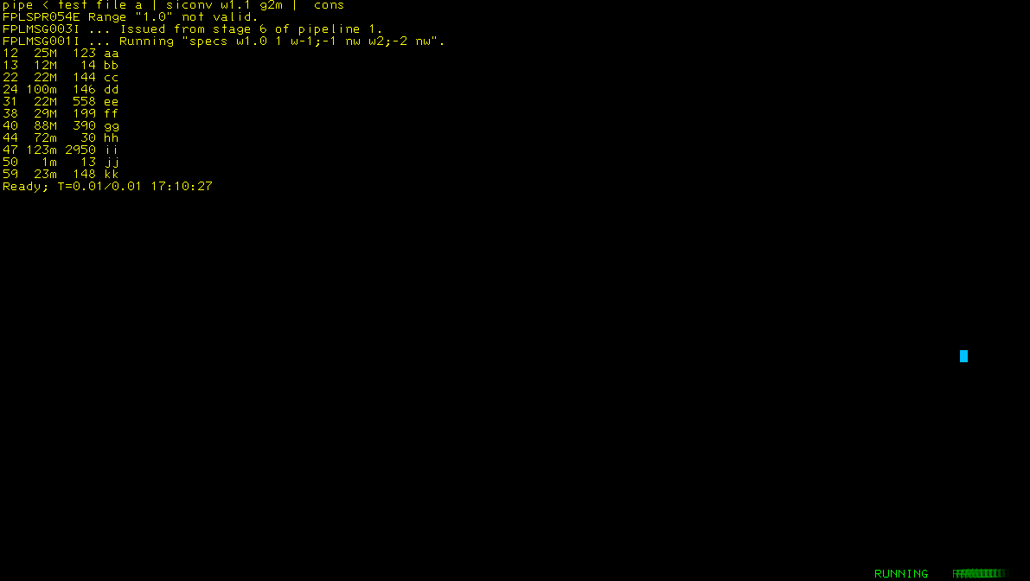
- Nope, that did not work like we expected, some adjustments needed
/* SICONV REXX convert from 1 SI unit to another */

numeric digits 64 /* So we see the numbers */
/*---------------------------------------------------------------+
| The units we are going to support... |
+---------------------------------------------------------------*/
/** B = to or from Bytes **/
B=1
K=1024 /* Kilo */ ; M=K*K /* Mega */ ; G=M*K /* Giga */
T=G*K /* Tera */ ; P=T*K /* Peta */ ; E=P*K /* Exa */
Z=E*K /* Zeta */ ; Y=Z*K /* Yotta*/
units='B K M G T P E Z Y'
defpict='--------------------9.99999'
/*---------------------------------------------------------------+
| Getting the input |
+---------------------------------------------------------------*/
Parse Upper Arg argline
/*---------------------------------------------------------------+
| We expect input like: w2.1 m2g w3.1 b2g |
| We will cater for w and word |
+---------------------------------------------------------------*/
'CALLPIPE (end ?)',
'*:', /* Read all records from caller */
'| buffer', /* Prevent stall */
'| stem input.', /* Store as */
'?', /* A 2nd pipe started */
'var argline', /* Take this */
'| change anycase °WORD°W°', /* Replace this */
'| split before string °W°', /* Split here */
'| stem argum.' /* Store as array */
/*---------------------------------------------------------------+
| Loop thru the input with 2 words at a time |
+---------------------------------------------------------------*/
Do a=1 To argum.0
Parse Value argum.a With loc cnv pict . /* Split into usable parts */
Parse Value loc With 'W'strt'.'len . /* Split into start and length */
Parse Value cnv With fr'2'to . /* Split into from and to */
/*---------------------------------------------------------------+
| Processing the picture if present |
+---------------------------------------------------------------*/
If pict<>'' Then Do
Parse Value pict With predec'.'postdec .
pict=Copies('-',predec-1)'9'
If postdec<>'' Then pict=pict'.'Copies('9',postdec)
End
Else pict=defpict
/*---------------------------------------------------------------+
| Change the layout... |
+---------------------------------------------------------------*/
If strt=1 Then rework='w-1;-1 1 w'strt+len';-2 nw' /* If it is 1 we need different action */
Else rework='w1.'strt-1' 1 w-1;-1 nw w'strt+len';-2 nw' /* Do some rework */
Call Check_Conversion
Interpret('factor='fr) /* We need to multiply by this */
Interpret('diviso='to) /* We need to divide by this */
'CALLPIPE (End ?)',
'stem input.', /* Take this stem */
'| buffer', /* Prevent a loop */
'| change anycase 'loc' °'fr'°°', /* Remove the SI sign if present */
'| specs 1;* 1', /* Take the complete record */
' u: 'loc' .', /* Select this column */
' set #0:=u*'factor, /* Start the multiplication */
' print #0 picture 'pict' nw', /* Add to the end of the record */
'| specs w1;-2 1', /* Take the record minus the last column */
' v: w-1;-1 .', /* Take the last column/word */
' set #1:=v/'diviso, /* Divide it */
' print #1 picture 'pict' nw', /* Adjusting layout using picture */
'| specs 'rework, /* Re-align the layout of the records */
'| stem input.' /* Rewrite the stem */
End a
/*---------------------------------------------------------------+
| Send the changed records to the caller... |
+---------------------------------------------------------------*/
'CALLPIPE (end ?)',
'stem input.', /* Take the stem */
'| *:' /* Feed 2 caller */
Return

Check_Conversion:
/*---------------------------------------------------------------+
| Check if the conversion is correct... |
+---------------------------------------------------------------*/
If fr=to Then Do /* They are equal, unneeded */
Say cnv 'is invalid'
Exit 99
End
If Pos(fr,units)=0 Then Do /* From is not valid */
Say fr 'in 'cnv' is invalid'
Exit 99
End
If Pos(to,units)=0 Then Do /* To is not valid */
Say to 'in 'cnv' is invalid'
Exit 99
End
Return

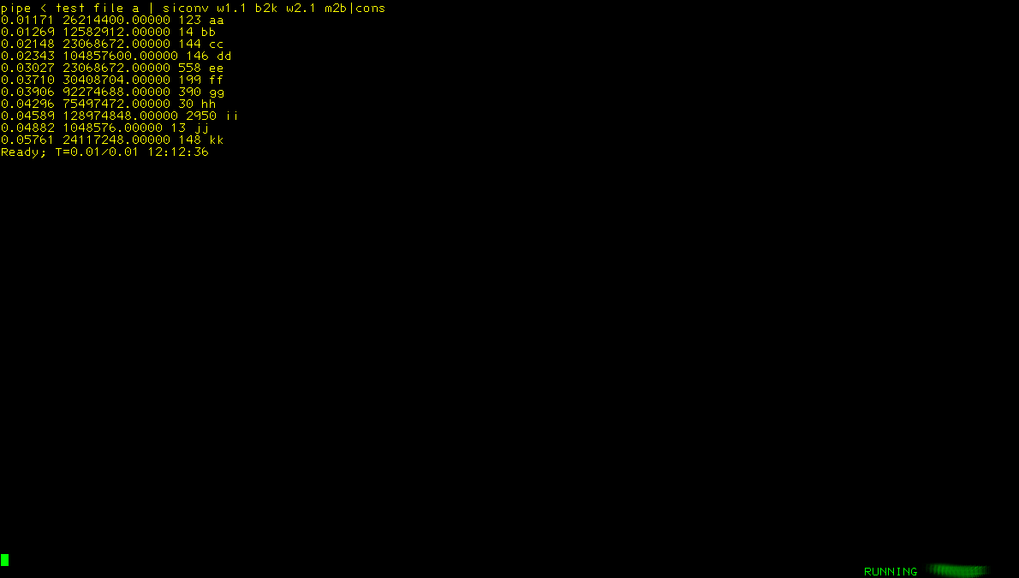
- Not satisfied, I want to control the how many characters before and after the decimal point and sometimes I want to see the new SI unit
/* SICONV REXX convert from 1 SI unit to another */

/* numeric digits 64 /* So we see the numbers */ */
/*---------------------------------------------------------------+
| The units we are going to support... |
+---------------------------------------------------------------*/
/** B = to or from Bytes **/
B=1
K=1024 /* Kilo */ ; M=K*K /* Mega */ ; G=M*K /* Giga */
T=G*K /* Tera */ ; P=T*K /* Peta */ ; E=P*K /* Exa */
Z=E*K /* Zeta */ ; Y=Z*K /* Yotta*/
units='B K M G T P E Z Y'
defpict='--------------------9.99999'
/*---------------------------------------------------------------+
| Getting the input |
+---------------------------------------------------------------*/
Parse Upper Arg argline
/*---------------------------------------------------------------+
| We expect input like: w2.1 m2g 9.4 w1.1 b2g 10.5 x |
| We will cater for w and word |
+---------------------------------------------------------------*/
'CALLPIPE (end ?)',
'*:', /* Read all records from caller */
'| buffer', /* Prevent stall */
'| stem input.', /* Store as */
'?', /* A 2nd pipe started */
'var argline', /* Take this */
'| change anycase °WORD°W°', /* Replace this */
'| split before string °W°', /* Split here */
'| stem argum.' /* Store as array */
/*---------------------------------------------------------------+
| Loop thru the input with 2 words at a time |
+---------------------------------------------------------------*/
Do a=1 To argum.0
Parse Value argum.a With loc cnv pict siunit . /* Split into usable parts */
Parse Value loc With 'W'strt'.'len . /* Split into start and length */
Parse Value cnv With fr'2'to . /* Split into from and to */
If siunit<>'' Then siunit=to
Else siunit=''
/*---------------------------------------------------------------+
| Processing the picture if present |
+---------------------------------------------------------------*/
If pict<>'' Then Do
Parse Value pict With predec'.'postdec .
pict=Copies('-',predec-1)'9'
If postdec<>'' Then pict=pict'.'Copies('9',postdec)
End
Else pict=defpict
/*---------------------------------------------------------------+
| Change the layout... |
+---------------------------------------------------------------*/
If strt=1 Then rework='w-1;-1 1 °'siunit'° n w'strt+len';-2 nw' /* If 1 need different action */
Else rework='w1.'strt-1' 1 w-1;-1 nw °'siunit'° n w'strt+len';-2 nw' /* rework */
Call Check_Conversion
Interpret('factor='fr) /* We need to multiply by this */
Interpret('diviso='to) /* We need to divide by this */
'CALLPIPE (End ?)',
'stem input.', /* Take this stem */
'| buffer', /* Prevent a loop */
'| change anycase 'loc' °'fr'°°', /* Remove the SI sign if present */
'| specs 1;* 1', /* Take the complete record */
' u: 'loc' .', /* Select this column */
' set #0:=u*'factor, /* Start the multiplication */
' print #0 picture 'pict' nw', /* Add to the end of the record */
'| specs w1;-2 1', /* Take the record minus the last column */
' v: w-1;-1 .', /* Take the last column/word */
' set #1:=v/'diviso, /* Divide it */
' print #1 picture 'pict' nw', /* Adjusting layout using picture */
'| specs 'rework, /* Re-align the layout of the records */
'| stem input.' /* Rewrite the stem */
End a
/*---------------------------------------------------------------+
| Send the changed records to the caller... |
+---------------------------------------------------------------*/
'CALLPIPE (end ?)',
'stem input.', /* Take the stem */
'| *:' /* Feed 2 caller */
Return

Check_Conversion:
/*---------------------------------------------------------------+
| Check if the conversion is correct... |
+---------------------------------------------------------------*/
If fr=to Then Do /* They are equal, unneeded */
Say cnv 'is invalid'
Exit 99
End
If Pos(fr,units)=0 Then Do /* From is not valid */
Say fr 'in 'cnv' is invalid'
Exit 99
End
If Pos(to,units)=0 Then Do /* To is not valid */
Say to 'in 'cnv' is invalid'
Exit 99
End
Return
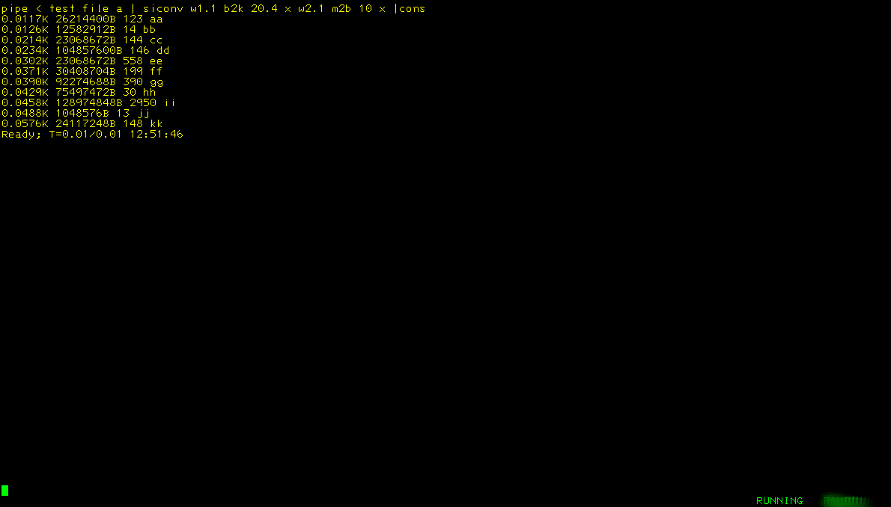
- All that is left is adding a header and some text
/*---------------------------------------------------------------+
| Function : Convert words from one si-unit to an other. |
| |
| File : SICONV REXX |
+----------------------------------------------------------------+
| Version : 1.1.0 |
| |
| Files : none |
| |
| Called : SICONV <word> <conversion> <picture> <si-unit> |
| |
| <word> is W<start>.<length> |
| Examples: word2.1 , w1.1 |
| |
| <conversion> convert from si-unit x to si-unit y |
| Examples: M2K, megabyte to kilobyte. G2M, gigabyte |
| to megabyte, etc. |
| |
| <picture> Optional, defines how many characters are |
| before and after the decimal point |
| Examples: 10.5, 5.5, 8 |
| |
| <si-unit> Optional, any non-blank character to |
| signal that the si-unit needs to be |
| appended to the new value. |
| |
| Example : ..| siconv w2.1 k2b | ... |
| if w2.1 contains 1 the new content will be 1024 |
| if w2.1 contains 1k the new content will be 1024 |
| |
| : ..| siconv w5.1 m2k 12.2 | ... |
| if w5.1 contains 1345 the new content: 1377280.00 |
| |
| : ..| siconv w4.1 k2m 5.2 x | ... |
| if w5.1 contains 1345 the new content: 1.31M |
| |
| |
| Comments : If the word contains the si-unit it will be |
| stripped automatically |
| |
| Author : H.T.Kramer, , |
| Created : 20200812 12:52:54 |
| Changes : . |
| |
+---------------------------------------------------------------*/
/*---------------------------------------------------------------+
| The units we are going to support... |
+---------------------------------------------------------------*/
B=1 /* Byte(s) */
K=1024 /* Kilo */ ; M=K*K /* Mega */ ; G=M*K /* Giga */
T=G*K /* Tera */ ; P=T*K /* Peta */ ; E=P*K /* Exa */
Z=E*K /* Zeta */ ; Y=Z*K /* Yotta*/
units='BKMGTPEZY' /* To be able to check the conversions */
defpict='--------------------9.99999' /* Def. picture 20 before dec . and 5 after */
/*---------------------------------------------------------------+
| Getting the input |
+---------------------------------------------------------------*/
Parse Upper Arg argline
/*---------------------------------------------------------------+
| We process the input and the arguments here |
+---------------------------------------------------------------*/
'CALLPIPE (end ?)',
'*:', /* Read all records from caller */
'| buffer', /* Prevent stall */
'| stem input.', /* Store as */
'?', /* A 2nd pipe started */
'var argline', /* Take this */
'| change anycase °WORD°W°', /* Replace this */
'| split before string °W°', /* Split here */
'| stem argum.' /* Store as array */
/*---------------------------------------------------------------+
| Loop thru the input with 2 words at a time |
+---------------------------------------------------------------*/
Do a=1 To argum.0
Parse Value argum.a With loc cnv pict siunit . /* Split into usable parts */
Parse Value loc With 'W'strt'.'len . /* Split into start and length */
Parse Value cnv With fr'2'to . /* Split into from and to */
If siunit<>'' Then siunit=to
Else siunit=''
/*---------------------------------------------------------------+
| Processing the picture if present |
+---------------------------------------------------------------*/
If pict<>'' Then Do
Parse Value pict With predec'.'postdec .
pict=Copies('-',predec-1)'9'
If postdec<>'' Then pict=pict'.'Copies('9',postdec)
End
Else pict=defpict
/*---------------------------------------------------------------+
| Change the layout... |
+---------------------------------------------------------------*/
If strt=1 Then rework='w-1;-1 1 °'siunit'° n w'strt+len';-2 nw' /* If 1 different action */
Else rework='w1.'strt-1' 1 w-1;-1 nw °'siunit'° n w'strt+len';-2 nw' /* rework */
Call Check_Conversion
Interpret('factor='fr) /* We need to multiply by this */
Interpret('diviso='to) /* We need to divide by this */
'CALLPIPE (End ?)',
'stem input.', /* Take this stem */
'| buffer', /* Prevent a loop */
'| change anycase 'loc' °'fr'°°', /* Remove the SI sign if present */
'| specs 1;* 1', /* Take the complete record */
' u: 'loc' .', /* Select this column */
' set #0:=u*'factor, /* Start the multiplication */
' print #0 picture 'defpict' nw', /* Add to the end of the record */
'| specs w1;-2 1', /* Take the record minus the last column */
' v: w-1;-1 .', /* Take the last column/word */
' set #1:=v/'diviso, /* Divide it */
' print #1 picture 'pict' nw', /* Adjusting layout using picture */
'| specs 'rework, /* Re-align the layout of the records */
'| stem input.' /* Rewrite the stem */
End a
/*---------------------------------------------------------------+
| Send the changed records to the caller... |
+---------------------------------------------------------------*/
'CALLPIPE (end ?)',
'stem input.', /* Take the stem */
'| *:' /* Feed 2 caller */
Return

Check_Conversion:
/*---------------------------------------------------------------+
| Check if the conversion is correct... |
+---------------------------------------------------------------*/
If fr=to Then Do /* They are equal, unneeded */
Say cnv 'is invalid'
Exit 99
End
If Pos(fr,units)=0 Then Do /* From is not valid */
Say fr 'in 'cnv' is invalid'
Exit 99
End
If Pos(to,units)=0 Then Do /* To is not valid */
Say to 'in 'cnv' is invalid'
Exit 99
End
Return

